## IHQ:Logos_Photos_ALL:01-TTS+Sections:TTS_seal_541.epslogo ISNISN –TTS Sister Transplant Center Program Manual – 2015

## C Level Center Partnership (Pairs)

## This manual is designed to explain the guidelines for participating centers in the ISN-TTS Sister Transplant Program (pairs) in accordance with privileges allowed for Level C.

We wish to point out the following to Sister Transplant Center program participants:

* **The financial support (budget) and services (in–kind donations) provided by ISN and TTS are only intended to provide a framework among the Centers and to reinforce the goodwill that stems from the Supporting Sister Center**. ISN and TTS funding is not intended to form the sole basis of what should ideally be a long lasting and fruitful collaboration between the Centers. The grant funds must only be used for the educational activities agreed upon jointly by the Sister Transplant Centers and carried out at the initiative of either the Emerging Center or Supporting Center in the context of the Sister Transplant Centers Program and cannot be used for the private benefit of any institution. ISN and TTS’s support cannot carry all expenses linked to the development of an Emerging center and the joint activities undertaken between centers.

**ISN and TTS require the pairs to be responsible by respecting the formalities and deadlines described in this document in order to ensure the provision of our support**. ISN-TTS staff will not send multiple reminders and follow-ups in order for ISN-TTS to be able to provide you with a unique opportunity for support and development via funding.

## This manual comprises six sections:

## 1: Sister Transplant Center Objectives (p.2)

## 2: Progress Reports & Upgrade (p.2)

## 3: Explanation of Financial Support and Guidelines (p.3)

## 4: Description of In Kind Support Items (p.6)

## 5: Dates to Remember: (p.8)

6: World Kidney Day (p.9)

This manual will refer to the Supporting Center as ‘SC’, the Emerging Center as ‘EC’.

All forms referred to in this manual can be downloaded from the Sister Transplant Center Webpage on the [ISN website](http://www.theisn.org/programs/sister-renal-centers-program?showall=&start=3) or [TTS website](https://www.tts.org/index.php?option=com_content&view=article&id=1260&Itemid=784).

For any additional details or inquiries, please always contact ISN Global Operations Center, as shown here below:

#### ISN Global Operations Center

Ms. Christine Rugurika

Global Outreach Programs Coordinator

Rue des Fabriques 1B

1000 Brussels, Belgium

Tel: +32 2 808 0420

Fax: +32 2 808 4454

[crugurika@theisn.org](mailto:gmanuzi@theisn.org)

## 1: STC Objectives

The ISN-TTS Sister Transplant Center program aims at enhancing the clinical practice of transplantation at Emerging Centers through a variety of training exchanges between SC and EC. The key objectives of each Sister Transplant Center link are:

1. **Clinical staff training:** Multidisciplinary training exchanges between the EC and the SC, senior scholarship visits from the SC to the EC - will account for up to 40% of the scoring.
2. **Education**: Local and regional CMEs, provision of education materials at the EC, attendance on training courses whilst on training attachments at the SC will account for up to 20% of the scoring.
3. **Upgrade of clinical services:** Evidence of expansion of local and regional clinical transplantation facilities and services - will account for up to 20% of the scoring.

The Sister Transplant Center Program has a series of progressive steps associated with increasing funding as the partnership between the EC and SC grows. The steps to Level B and Level A are competitive and are awarded according to achievement at Level C and B respectively. Normally each stage last for 2 years and the initial Level C stage comes with limited funding and should be used as an exploratory phase to investigate feasibility of a training link and establish a program of joint interaction for the multidisciplinary team from both the EC and SC. The diagram below provides an overview of the progressive nature of the Sister Transplant Center Program and eligibility levels.

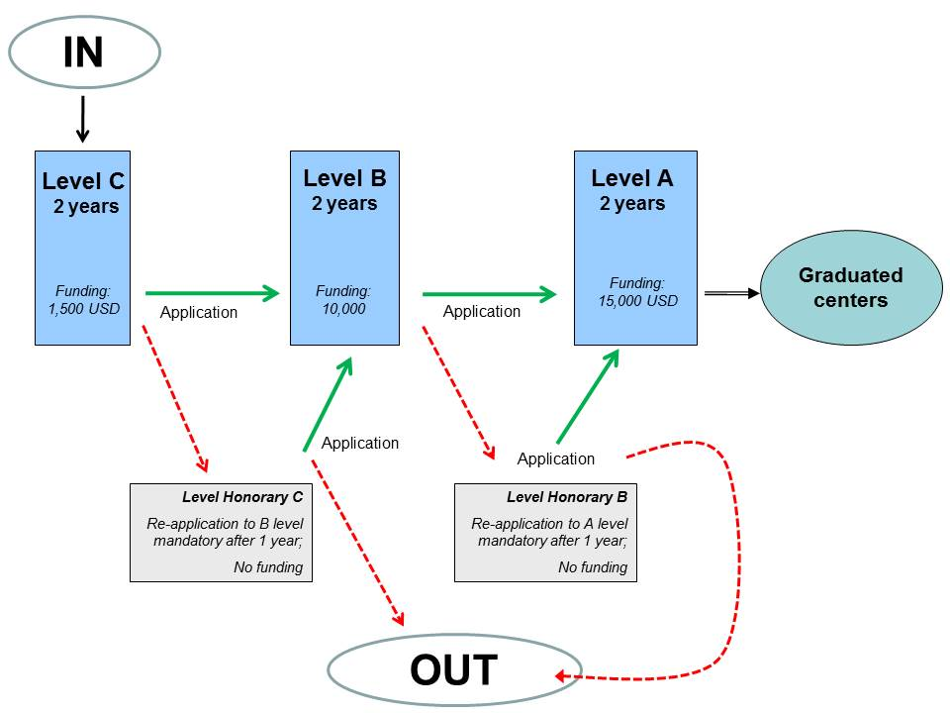

The ultimate goal is for Level A centers to graduate and become true local centers of excellence for regional training and support.

## 2: Progress Reports & Upgrade

In order for the Sister Transplant Center Committee to evaluate the level of activity and commitment between the sister Centers as well as to assess the appropriate use of the funding, the C level centers are required to submit an annual report at the end of the year. The report constitutes the basis for granting priorities or upgrades at a later stage as well as releasing further funding.

The report should include all activities undertaken between the centers and describe the support that has already been provided. An analysis of what has been achieved and how the status of the EC has progressed would provide a very helpful insight to the Sister Transplant Center Committee.

The progress reports will be very short and will address the following items:

* Names of persons involved
* Dates
* Budget breakdown for each activity and brief description
* Confirmation of forthcoming activities (incl. names, dates, required budget)

Please note that the report constitutes the primary basis to review pairs’ achievements. The Sister Transplant Center committee takes indeed into account the annual report of the year before and the proposed budget plan at the time of reviewing applications for upgrades. Therefore we remind you that the scoring parameters for upgrades are greatly influenced by previous activities and results.

Suitability for upgrade will be determined considering the following:

**Key 3 criteria (see section 1):** (this accounts for up to 80% of the scoring)

1. Clinical staff training
2. Education
3. Upgrade of clinical services

**Secondary criteria:** (this accounts for 10-20% of the scoring)

1. Community-orientation including evidence of participation in World Kidney Day
2. Clinical research activities at the EC
3. Relay of knowledge through regional, national and international meetings and publications

Please note that the Sister Transplant Center Committee has the possibility of extending the duration of the Sister Transplant Center Level of an individual pair for longer than 2 years under exceptional circumstances at the Committee’s discretion.

## 3: Explanation of Financial Support and Guidelines

The ISN-TTS Sister Transplant Center Program is bound by a limited budget which it cannot exceed. This budget is divided over all center pairs who receive a different financial allocation dependant on their level within the program.

**A level links receive an annual allocation of maximum 15,000 USD**

**B level links receive an annual allocation of maximum 10,000 USD**

**C level links receive an annual allocation of maximum 1,500 USD**

Standard formats that are approved for support are for instance:

* Travels from EC to SC (training visits, short team training visits, etc.)
* Travels from SC to EC (senior scholarship visit)
* Travel grants or supplements (limited to 10% of the annual ISN-TTS funding) No more than 150 USD can be spent on travel grant supplement whilst at Level C.
* Other educational activities/projects

Please note that the ISN -TTS Sister Transplant Center grant is an educational grant and not a service grant**. It is therefore greatly discouraged to spend budget on equipment** (such as regular patient care or research laboratory equipment or individual patient immunosuppression).

The allocated budget will be paid in the course ofJanuary 2015 to an account of the SC.

Prior to providing step by step guidelines here below we wish to stress two important facts which Center pairs must be aware of:

1. **It is of crucial importance that you keep a record of all expenses in order to detail them in your annual reports.**
2. **Your budget MUST be spent in this current year and unclaimed budget will not be added to your budget of the next program year.**

**NB:** THIS IS A VERY IMPORTANT BONUS OF ISN-TTS Sister Transplant Centre Status

**READ VERY CAREFULLY:**

ISN offers 4 other very exciting Global Outreach Programs: the Fellowship, the Educational Ambassadors Program, the CME and the Clinical Research and Prevention Programs. Centers taking part in the Sister Transplant Centre program are entitled to apply for additional funding through all GO programs (as listed above). For instance the Fellowship program could fund short term visits (2-6 months) for the EC to the SC/MC. In addition to eligibility for extra funding, Sister Transplant Centers will also receive extra points during the review process; so have a very high chance of success if applications are appropriate.

Visit the ISN website for more information:

[http://www.theisn.org/go](http://www.theisn.org/programs)

ISN and TTS also provide several in-kind support items to the pairs; these are described on page 6.

**Instructions regarding payment of allocated budget**

**STEP 1: Annual Budget Request by October 1st**

Each ISN TTS Sister Transplant Center partnership is requested to make an initial annual plan and corresponding estimated budget breakdown for the activities taking place the next year **by November 2015**. Please note that **a timely submission is mandatory** in order for you to benefit from your allocated budget.

* Pairs applying for an upgrade in the following year must submit by email to [Giorgia Manuzi](mailto:gmanuzi@theisn.org) the annual budget along with their other required documents for application to an upgrade by November 2015.
* Pairs not yet eligible for an upgrade must also submit the annual budget plan by **November 2015** in order for the Sister Transplant Center Committee to review it for implementation in the next year.

The annual budget plan is to be submitted via ‘[Form 1: annual budget request’](http://www.theisn.org/images/TEMPLATE_Annual_Budget_Proposal.doc) you may also be required to provide the necessary information for payment arrangements at this time.

Please note that that your budget request is to reflect the maximum budget allocated by the Sister Transplant Center program in the level you are applying for or remaining in; therefore *do not indicate in the form any activities you are planning to undertake with exterior sources of funding*. (These can be reported in the annual progress report).

The Sister Transplant Center Committee will review all annual budget requests based on the educational merit and benefit for the EC. If necessary they will seek the advice of the respective regional committees to evaluate the appropriateness and relevance of the proposed activities. The budget requests will either be discussed with the pair if further explanations/modifications are needed, or approved.

We realise that these initial plans may be subject to change due to visa issues, acts of god, personal and health situations, etc. Changes to the initial plan and alternative suggestions for the use of funding (of an educational nature) can be accommodated only under exceptional circumstances at the Sister Transplant Center Chairman’s discretion and as long as the ISN-TTS staff is duly informed.

**STEP 2: Notification of Approval in December**

By mid-December you will be notified about the status of your application and/or the approval of your budget plan.

**STEP 3: Signature of Grant Agreement and Payment in January - February**

Sister Transplant Center partnerships will be asked to sign a Grant Agreement in which you guarantee to use the funds allocated to you in the sole goal of advancing transplantation in the EC’s region. Once this is sent back to the ISN-TTS office, it is expected that the first payment will be made to the SC within the following weeks This payment is to be used for the planned activities held during the year. The SC will be responsible for distributing the money to the rightful recipients.

**STEP 4 Submission of applications and annual activity plan/budget in September**

Sister Transplant Center pairs will be invited to apply for upgrade if eligible. The relevant information and forms to fill will be sent to you by email in the course of August. You will be asked to provide an annual budget plan along with a report of activities of the current year and the previous year’s annual report. Additional documents/ information may be asked. Detailed information and instructions will be sent to you in due course. Pairs that are not eligible for upgrade will be asked to submit an annual budget plan for the next year at the same level in the program.

**STEP 5: Annual Progress Report in October 2015**

By October 15th a final progress report (via a provided template) is to be submitted. A detailed description of the activities undertaken in the course of the year as well as a brief reconfirmation of the activities foreseen for the remainder of the year will be asked.

**STEP 6: Final Accounting**

Sister Transplant Center partnerships who did not spend the money paid out to them will be requested to reimburse the unused fund to the ISN and TTS at the end of the year. Non-compliance with this may result in the removal from the program in the following year.

**Additional Notes Regarding Payment and Practical Arrangements**

**Rolling Over of Funds to the Next Year**

Funds which are allocated in one year but are not used cannot be rolled over for activities in the next yearexcept for EXTENUATING CIRCUMSTANCES such as sickness, visa refusals or acts of God (late organisation is not an extenuating circumstance); i.e. **unclaimed budget will not be added to your budget of the next program year.**

**Surplus Funds**

Pairs who have some surplus (due to activities costing less than foreseen or other justifiable reasons) may re-allocate the funds towards journal subscriptions, textbooks, registration/attendance to CMEs and congresses, or any other items of educational merit as long as these are paid for in the same program year and submitted for approval.

**Invoices and Receipts**

Invoices or receipts are not required Indeed the signature of the Grant Agreement exempts you from doing this as the money you receive can be considered as a “grant”.

**Visa procurement letters for travelers:**

If necessary, it is highly recommended that the traveller(s) make arrangements for a **visa** procurement as soon as possible seeing as this often takes several months and is in some unfortunate cases declined. Please be aware that the Global Operations Center can provide an official letter for the embassy/consulate if necessary; please provide the first and last name, place and date of birth, country of origin and passport number and expiry date for the preparation of this letter.

**Liability statement for travelers:**

Please note that upon an individual’s acceptance to travel and volunteer on behalf of ISN and TTS they acknowledge and accept that the International Society of Nephrology (ISN) and the Transplantation Society (TTS) cannot be held liable for any consequences related to travelling or staying abroad. The responsibility for procuring health/accident and travel insurances remains with the traveller; they or their relatives cannot hold the Societies (ISN and TTS) responsible in the event of untoward events or experiences.

## 4: Description of In Kind Support Items

Through ISN and other third parties (sponsors, partner societies) several in-kind support items have been arranged for your benefit. These items cannot be traded for cash support.

The benefits vary depending on the A, B or C level Status of the Sister Transplant Center pair.

|  |  |  |
| --- | --- | --- |
| **Items by ISN:** | ISN journal subscriptions | C, B & A |
| Certificates | C, B & A |
| Other ISN Programs-priority | C, B & A |
| WCN Travel Grants | 1 for B, 2 for A |
| Forefronts Travel Grants | A |
| Nexus Travel Grants-priority | C, B & A |
|  |  |
| **Items by TTS** | 50% reduction on TTS membership subscription | Emerging Centers |
|  |  |  |
| **Items by third parties:** | Other Society Journals | Depends on availability |
|  |  |
|  |  |

### Subscription to ISN Journals:

### The EC will receive a subscription to both Kidney International and Nature Clinical Practice Journals.

### We would like to stress that the journals are to be made freely accessible to all those for whom the journals are intended (physicians, student etc.) and that they are to be kept in a place accessible to all; the journals are not being granted for the benefit of only one or two selected individuals.

The password and ID are communicated upon joining the program; these remain the same for every following year that is spent in the program. The Journal will be sent to the attention of the liaison officer who is responsible for ensuring that the journal is shared and accessible.

### Certificates:

Certificates are issued to both the EC and SC when they are first accepted into the program (as well as with each upgrade to a higher level). The certificate is valid for two years or for as long as the center pair is active in the same level. Graduated A level pairs also receive a certificate.

IMPORTANT: PLEASE READ CAREFULLY!

**Priority Consideration for other ISN GO Programs**

1. CMEs

Requests submitted by an Sister Transplant Center pair to organize and host a CME, via the CME request form, will receive priority consideration by the CME Program Chairman; an application however does not guarantee that the meeting will be sponsored. Proposals for CMEs must be received at least 3-6 months in advance and reflect a serious organization of a meeting or course which fulfills an educational purpose, an appropriate scientific program and aim to gather a minimum of 50 persons. If the CME is approved for support; the economy travel of a maximum of 3 speakers will be covered by the ISN GO CME Program; accommodation of the speakers is to be provided and covered by the organizers. The CMEs are to be organized in conjunction between the EC and the SC usually as part of an ISN Sister Transplant Center Program event.

1. Fellowship, Clinical R&P and Educational Ambassadors Program

Applications, submitted by individuals from a participating Sister Transplant Center, will receive priority consideration in the review process by means of bonus points. The grants related to successful applications will be on top of the budget already received through the Sister Transplant Center program. Please be aware that an application is not guaranteed a successful outcome seeing as the criteria of the Fellowship, R&P and EAP programs prevail and they remain competitive in nature. In the unfortunate event that the Sister Transplant Center is unsuccessful at upgrading to the next level, it will not affect if a fellow from the EC has been accepted in the ISN Fellowship Program to train at the SC.

These additional means of development and growth for the EC (beyond provisions of the Sister Transplant Center program) are **strongly encouraged and will be favorably viewed** during applications for upgrade seeing as they are considered to be a demonstration of commitment to improving the level of transplantation at the EC.

**Travel Grant to WCN**

Pairs at level A and B are guaranteed to receive some travel grants for WCN provided they directly apply to the WCN organizers via the official WCN website.

The amount of the grant may change depending on WCN organization. Sister Transplant Center partnerships benefitting from a travel grant are requested to showcase a poster at WCN in order to display their achievements and promote the ISN-TTS Sister Transplant Center program. This will give the Sister Transplant Center Committee members the opportunity to meet with the pairs/trios and visualize their activities.

* A level centers pairs or trios may select one clinician from the EC and one junior clinician from the SC (unless agreed that both grants should go to the EC).
* B level centers pairs or trios may select one young clinician from the EC

Please note that the maximum number of travel grants that any individual may receive in a life time is now restricted to 3. This is a new policy designed to enable different persons to benefit from the grants.

The official WCN grant will be made available at the congress; the actual arrangements and confirmations are announced via a personal letter and depend on the WCN organization.

### Travel Grant to the ISN Nexus symposium:

The candidates who apply for a Nexus Travel Grant will receive priority points in the selection procedure, which is handled by the event organizers. Only one person per center can receive a travel grant; this is however not guaranteed and all usual selection criteria as imposed by the Nexus organizers will be upheld.

The candidates are to apply directly to the event organizers via the official Nexus Travel Grant application form, which will be posted on the ISN Gateway:

<http://www.isnnexus.org/berlin/travel-grants>

The next Nexus will be held in Berlin, Germany on April 14-17, 2015. The topic will be **“Translational Immunology in Kidney Disease”.**

**In-Kind Support Items Provided by the SC’s:**

Whilst this is not mandatoryit is encouraged; preferred forms of support (to list a few) could be a subscription to Up-to-date, subscription to a nephrology or transplantation journal, provision of textbooks or slides, travel and registration costs for an EC member to an international congress or CME, training support, technology and/or communication materials, machines, etc.

🡺 It is important that this support is detailed in the progress reports which will be reviewed in order to assess the level of goodwill and commitment between the partners.

## 5: Dates to Remember

**PROGRAMS:**

**October 1st, 2015:**

* Applications deadline for [ISN-TTS Sister Transplant Center Program](http://www.theisn.org/programs/sister-renal-centers-program?showall=&start=3)
* Applications deadline for [Educational Ambassadors Program](http://www.theisn.org/programs/educational-ambassadors-program-contact?showall=&limitstart=) - (Applications accepted from centers in developing countries), for [Clinical Research Program](http://www.theisn.org/programs/clinical-research-program) and for [Fellowship Program](http://www.theisn.org/programs/fellowship-program),

**November 2015:**

ISN-TTS pairs to submit the annual progress report.

**January/ February 2016:**

* **ISN-TTS approval of annual budget plans and announcement of application outcome**
* **Signature of Grant Agreement**
* **ISN-TTS Pairs to receive grant**

**May 1st, 2016**

* Applications deadline for [Educational Ambassadors Program](http://www.theisn.org/programs/educational-ambassadors-program-contact?showall=&limitstart=) - (Applications accepted from centers in developing countries), for [Clinical Research Program](http://www.theisn.org/programs/clinical-research-program) and for [Fellowship Program](http://www.theisn.org/programs/fellowship-program),

**October 1st, 2016:**

* Applications deadline for [ISN-TTS Sister Transplant Center Program](http://www.theisn.org/programs/sister-renal-centers-program?showall=&start=3)
* Applications deadline for [Educational Ambassadors Program](http://www.theisn.org/programs/educational-ambassadors-program-contact?showall=&limitstart=) - (Applications accepted from centers in developing countries), for [Clinical Research Program](http://www.theisn.org/programs/clinical-research-program) and for [Fellowship Program](http://www.theisn.org/programs/fellowship-program),

**EVENTS:**

**October 2015:**

* [ISN Forefronts Symposia](http://www.isnforefronts.org/shenzhen/) “Immunomodulation of Cardio-Renal Function: A focus on cardio-renal pathophysiology and immunity – Oct 22-25, 2015, Shenzhen, China

**November 2015:**

* ASN Renal Week, San Diego - November 3-8, 2015

**March 2016**

* [World Kidney Day](http://www.worldkidneyday.org/) - March 10, 2016

**April 2016:**

* [ISN Nexus Symposia](http://www.isnnexus.org/berlin/) "Translational Immunology in Kidney Disease" - April 14-17, 2016, Berlin, Germany

**6: World Kidney Day – Awareness and Prevention of Kidney Diseases!**

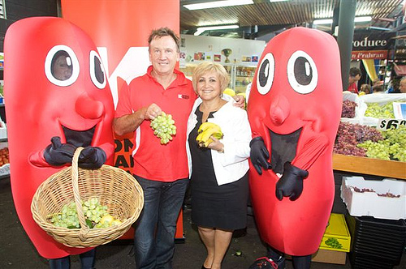World Kidney Day is celebrated worldwide on the second Thursday of March. It is an awareness campaign, which aims to raise awareness of the importance of our kidneys to our overall health and to reduce the frequency and impact of kidney disease and its associated health problems worldwide. World Kidney Day encourages high risk populations to be screened.

The events around the world offer a crucial and visible opportunity to inform and educate health policy-makers, people who are at highest risk of CKD, and the general public that kidney disease is common, harmful and treatable.

**Any involvement is meaningful!** People around the World celebrate World Kidney Day in different ways, whether it is by distributing flyers, organising a football game or organising a free screening event in a hospital.

For more detailed information about WKD, please visit the website: [World Kidney Day](http://www.theisn.org/initiatives/world-kidney-day), where ideas for action, campaign toolkits, posters, leaflets and other campaign material are available to help you prepare for the next World kidney Day.

[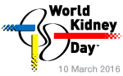](http://www.worldkidneyday.org/)